**1. What is the size of MBR and what does it contains.**

**The size is 512 B, it contains the address of GRUB.**

**2. In which file you can write commands which you want to run whenever Linux system starts/restarts?**

**Rc.local**

**3. Restart cron service.**

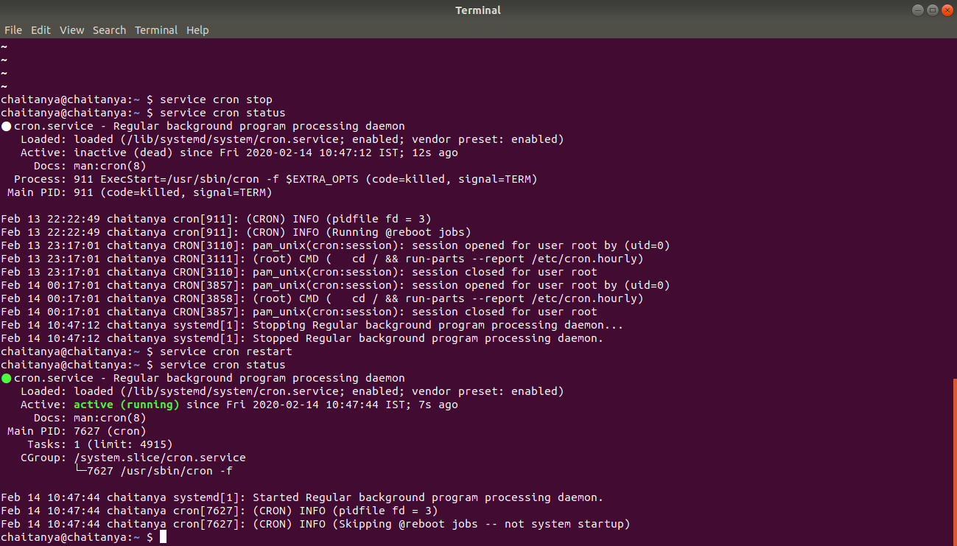

**4. Create an ext4 filesystem**

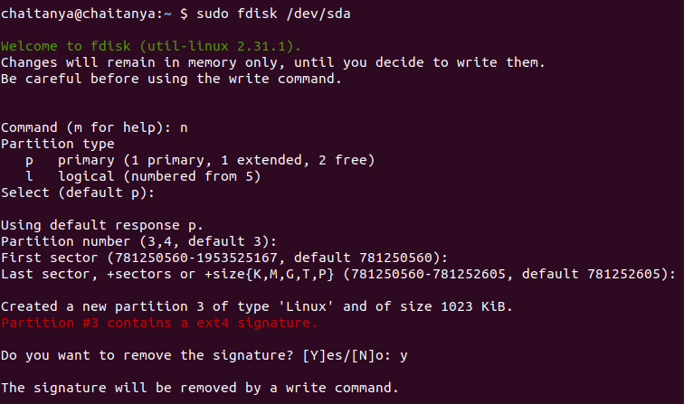

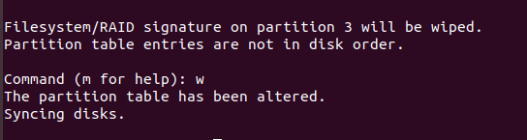

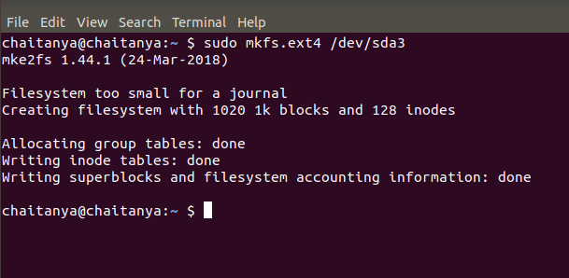

**5. Mount the created filesystem on /partition directory.**

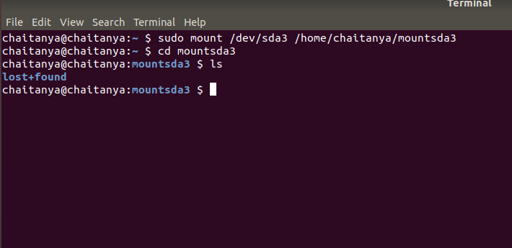

**6. Create a user and add it to one secondary group.**

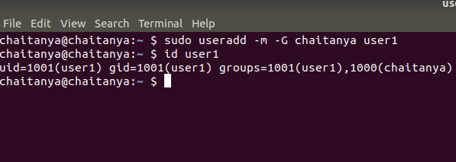

**7. Lock this user.**

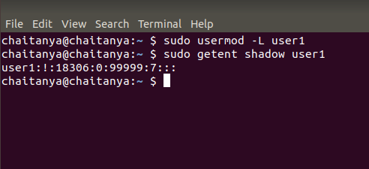

**8. Give this user full access (without password).**

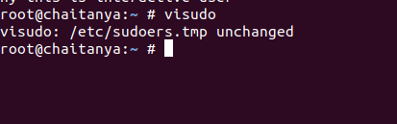

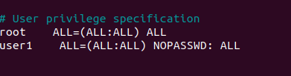

**9. Delete the create user after taking backup of it home directory.**

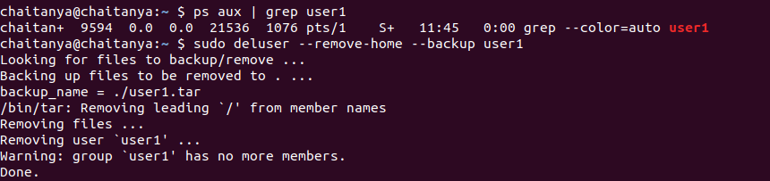

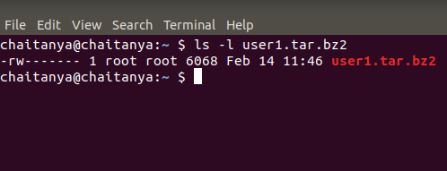

**10. Create a file with some content. Change all lower case letter to upper case letter and save output to another file using redirections.**

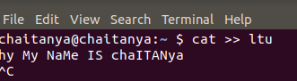

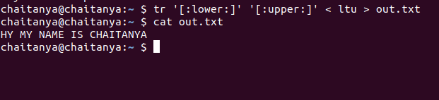

**11. Set nice value of a process to -1.**

**Renice -n 19 <pid>**

**12. Get list of all files used by “telnet”.**

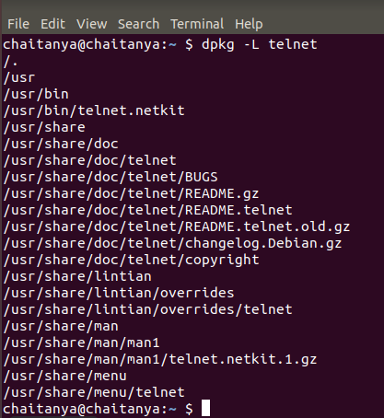

**13. Check if port 22 is listening using netstat and telnet command.**

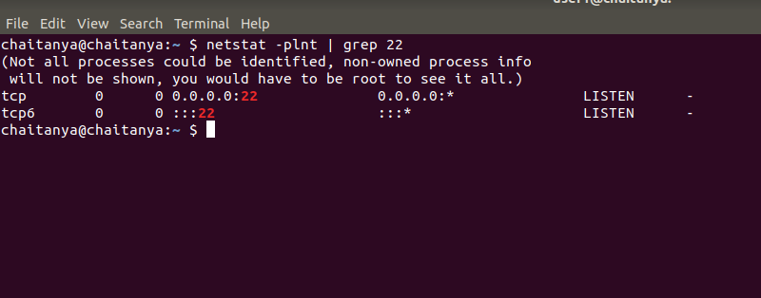

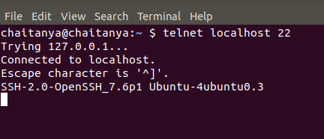

**14. Create a cron job which runs once in a week at 23:45.**

